Using the Ballarat Health Services SMART referral with Best Practice
These notes assume that:
- The most current SMART referral template has been added to Best Practice
- The template has not been added to the doctor’s Template favourites list.
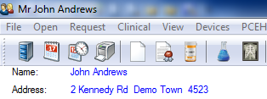

With the patient’s record open:

Click on the Letter Writer button.

Click on Templates:

Click on Use template

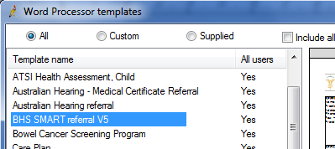

Scroll down until you see
BHS Smart Referral

Double click on it.

When the SMART referral window
pops up:

Click in the box if the patient is an Aboriginal or Torres Strait Islander.
Select Yes or No from the Interpreter list.

Select the Specialist from the list.
This is vital as it gives you the number to which the referral is to be faxed.

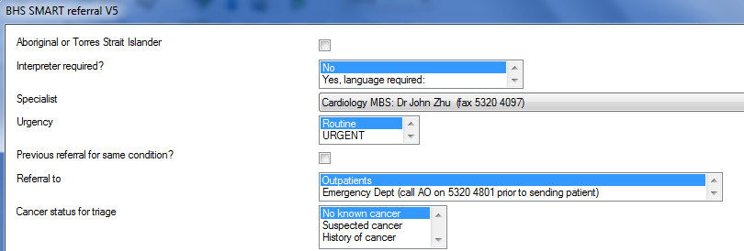
Choose Routine or URGENT from the Urgency list.

Click in the box if there has been a previous referral for the same condition.

Choose Outpatients or EMERGENCY from the Referral to list.

Choose the appropriate cancer status from the list.
PLEASE TURN OVER
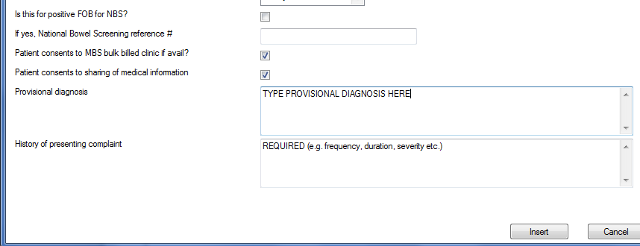
Click in the box if this is a National Bowel Cancer screening referral.

Enter the reference number if applicable.

Click in the boxes to indicate consent by the patient.

Type a provisional diagnosis.
Type the history of the presenting complaint.

Click on Insert.

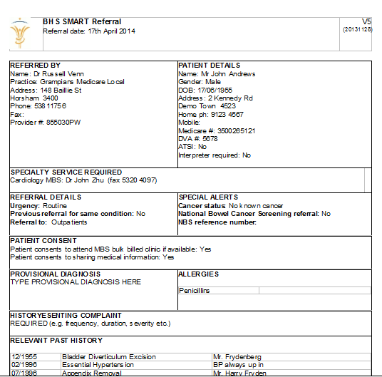

The referral is displayed on screen.

It contains information from the patient’s record as well as that which you have just entered.

Add any further information you think relevant, particularly any relevant results and investigations.

Print and save the referral.

Sign the referral at the bottom of the last page.

Fax it to the number displayed.

