Using the Ballarat Health Services SMART referral with Medical Director
These notes assume that:
- The most current SMART referral template has been added to Medical Director
- Ballarat Health Services is in the practice’s MD address book.

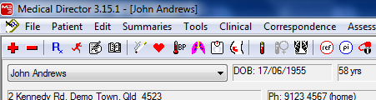
With the patient’s record open:

Click on the Letter Writer button.

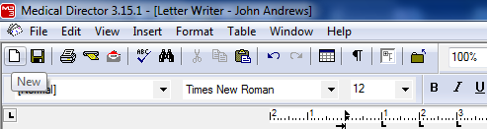
In the Letter Writer:

Click on the New button.

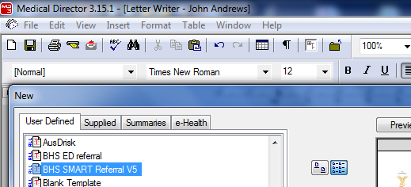

On the User Defined tab:

Scroll down until you see
BHS Smart Referral
Double click on it.
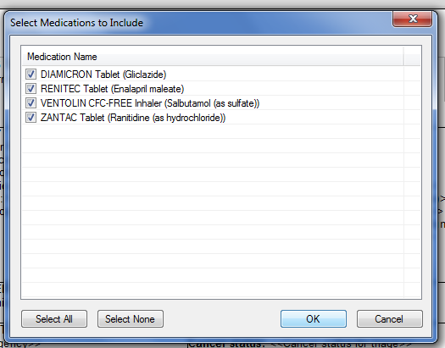

If the patient has any current medications, they
will be displayed.

Select the medications you want included in the
referral by clicking in the appropriate box,
or clicking on the Select All or
the Select None buttons.

Click OK.

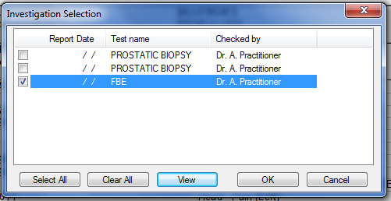
If the patient has any pathology or radiology
results, they will be displayed.

Select the results you want included in the
referral by clicking in the appropriate box,
or clicking on the Select All or
the Select None button.

Click OK
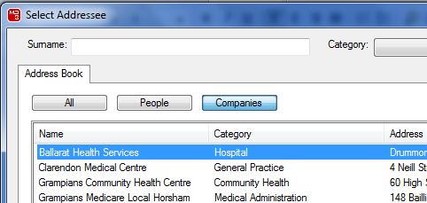

When the Select Addressee window pops
up, scroll down to Ballarat Health Services.

Double click on it.

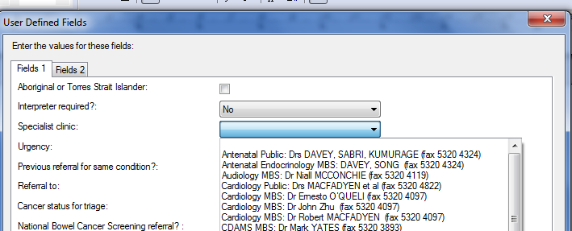

When the User Defined Fields window
pops up:

Click in the box if the patient is an Aboriginal or Torres Strait Islander.
Select Yes or No from the Interpreter list.

Select the Specialist Clinic from the list.
This is vital as it gives you the number to which the referral is to be faxed.

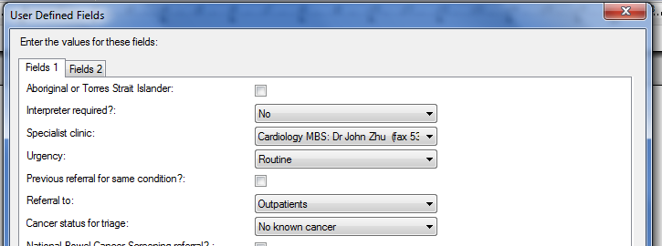
Choose Routine or URGENT from the Urgency list.

Click in the box if there has been a previous referral for the same condition.

Choose Outpatients or EMERGENCY from the Referral to list.

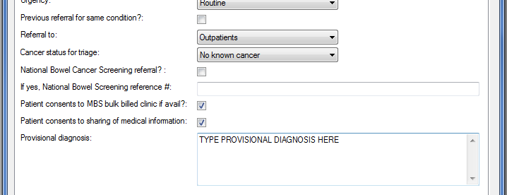
Choose the appropriate cancer status from the list.

Click in the box if this is a National Bowel Cancer screening referral.

Enter the reference number if applicable.

Click in the boxes to indicate consent by the patient.

Type a provisional diagnosis.

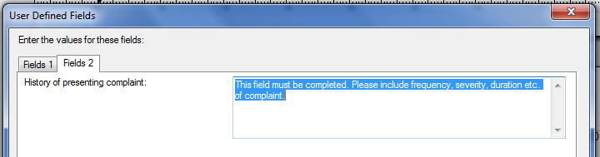
If you see the Fields 1 and Fields 2 tabs

Click on Fields 2.

Type the history of the presenting complaint.
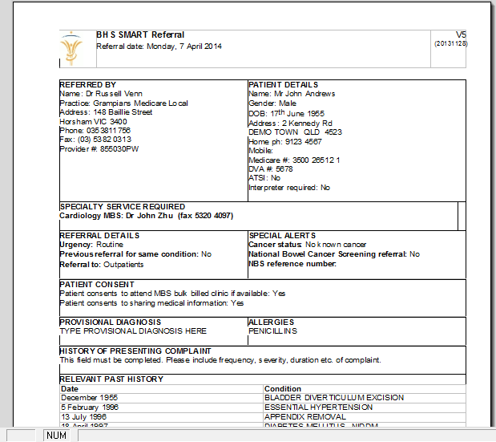
Click on OK.

The referral is displayed on screen.

It contains information from the patient’s record as well as that which you have just entered.

Add any further information you think relevant.

Print and save the referral.

Sign the referral at the bottom of the last page.

Fax it to the number displayed.

