Using the Ballarat Health Services SMART referral with Zedmed
These notes assume that:
- The most current SMART referral template has been added to Zedmed
- The template has been set to appear in the doctor’s Quick Documents list.
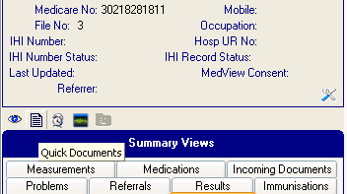

With the patient’s record open:

Click on the Quick Documents icon.

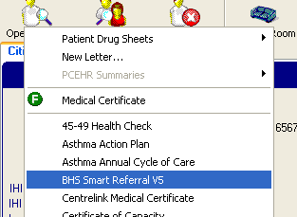

Locate BHS Smart Referral

Click on it.

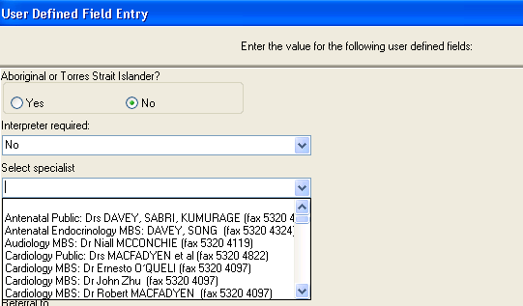

When the User Defined Field Entry window pops up:

Click on the button if the patient is an Aboriginal or Torres Strait Islander.

Select Yes or No from the Interpreter list.

Select the Specialist from the list.
This is vital as it gives you the number to which the referral is to be faxed.

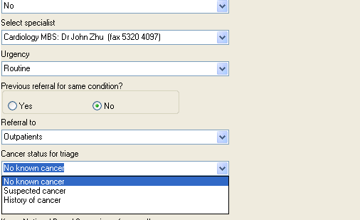

Choose Routine or URGENT from the Urgency list.

Click on the button if there has been a previous referral for the same condition.

Choose Outpatients or EMERGENCY from the Referral to list.

Choose the appropriate cancer status from the list.

Please turn over

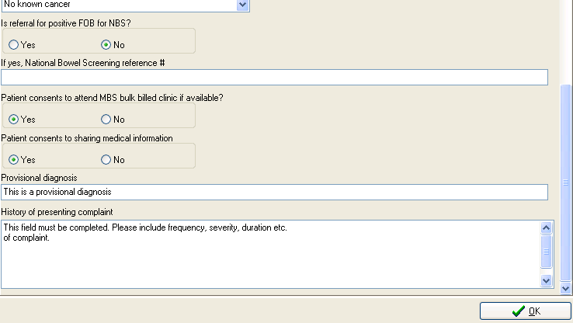
Click on the button if this is a National Bowel Cancer screening referral.

Enter the reference number if applicable.

Click on the buttons to indicate consent by the patient.

Type a provisional diagnosis.

Type the history of the presenting complaint.

Click on OK.

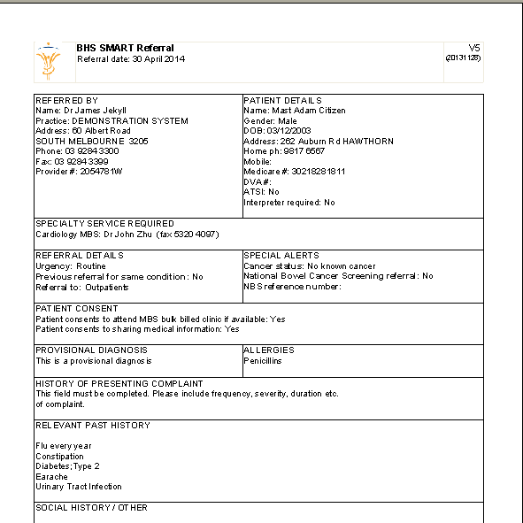

The referral is displayed on screen.

It contains information from the patient’s record as well as that which you have just entered.

Add any further information you think relevant.

Print and save the referral.

Sign the referral at the bottom of the last page.

Fax it to the number displayed.

