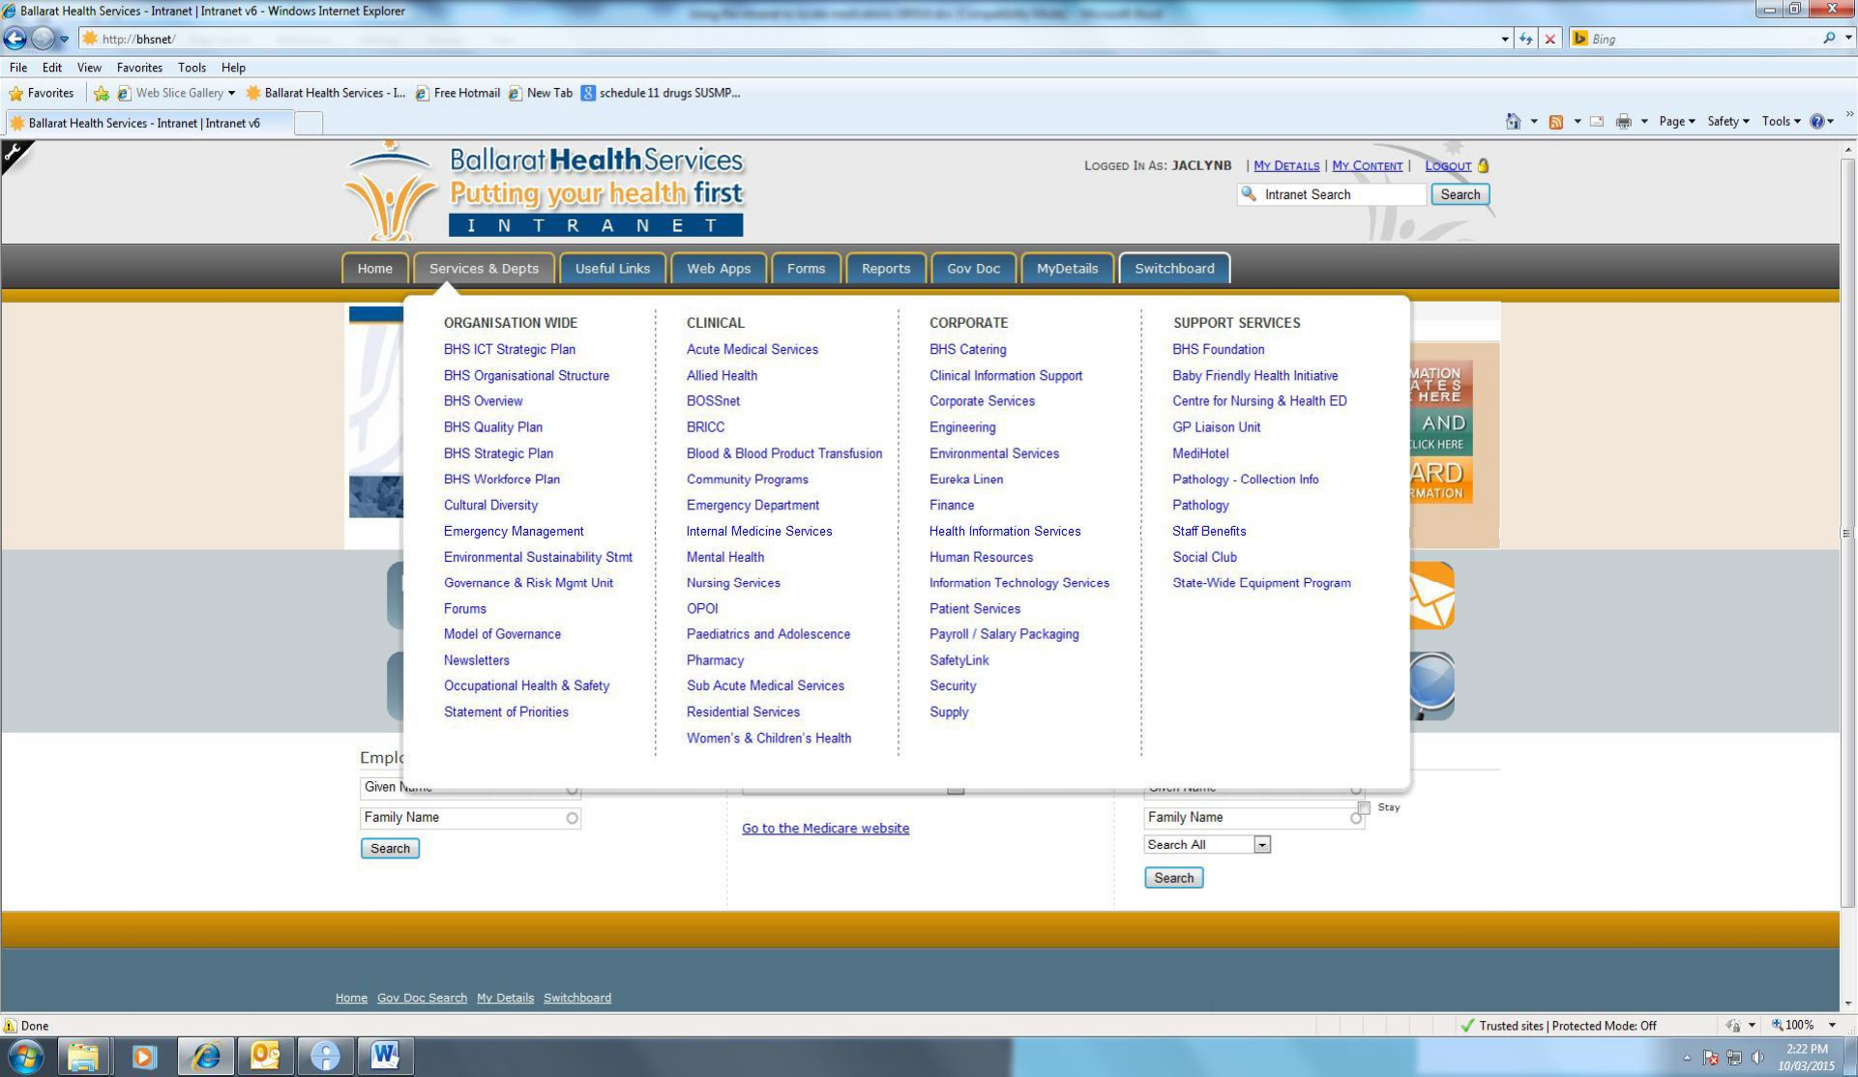

**After Hours: using the intranet to locate medicines**

1. Open the BHS intranet page

2. Click on the Services & Depts tab

3. Under Clinical Services, choose Pharmacy (to open the Pharmacy home page)

4. Scroll down to the heading Imprest

5. To determine the location of a drug, click on the link for Imprest Summary (sorted by generic name). This opens a PDF document.

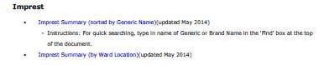

6. In the tool bar across the top, type the name of the drug you wish to locate in the “find” box and press enter to retrieve the result. If there is no tool bar, type Control & F to open up a “find” box.

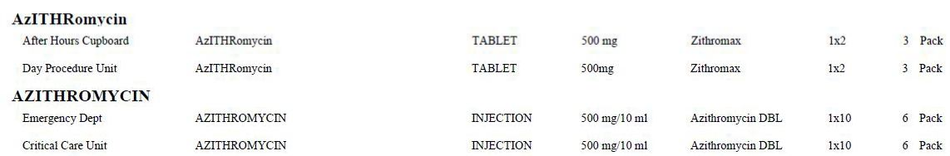

7. The location of the drug is shown in the first column (note that drugs kept only in pharmacy do not appear on this list). Check that it is the right form (e.g. oral versus intravenous) and that the strength is appropriate.

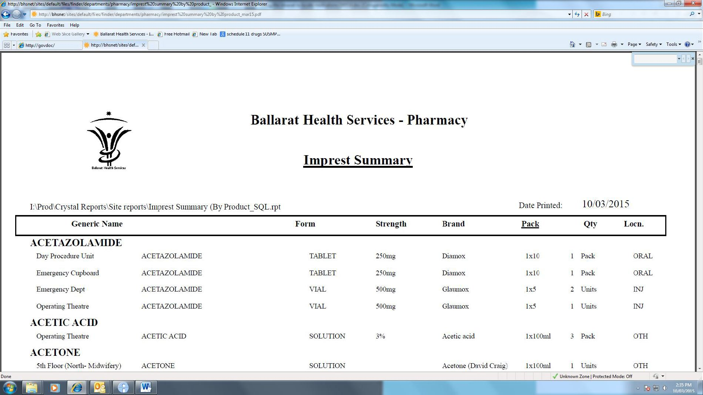

Location/s Form & strength Pack size & quantity

8. Staff should collect the medication required if it is located in a nearby ward/unit, otherwise contact the Patient Flow Coordinator/After Hours Coordinator for assistance.

9. If the drug does not appear on the list, and treatment is required to start outside of pharmacy hours, contact the Patient Flow Coordinator/After Hours Coordinator.